

**Faculty of engineering - Shoubra Benha University**

# Research Article / Research Project / Literature Review

in fulfillment of the requirements of

|  |  |
| --- | --- |
| **Department** | **Engineering Mathematics and Physics** |
| **Division** | ----------- |
| **Academic Year** | **2019-2020 Preparatory** |
| **Course name** | **Computer** |
| **Course code** | **ECE001** |

**Title: -**

**Internet of Things**

By:

|  |  |  |  |
| --- | --- | --- | --- |
|  | Name | Edu mail | B.N |
| 1 |  |  |  |

## Approved by:

|  |  |
| --- | --- |
| Examiners committee | Signature |
|  |  |
|  |  |
|  |  |
|  |  |
|  |  |

**Research objectives**

Internet of things the fact behind the word “smart” that comes before “smart homes”, “smart cities” and “smart wearables”.

This research is to cover some of IOT history and applications.

A website is created using HTML to highlight some of the internet of things application.

<https://m0ragab.github.io/html_project/index.html>

the website source code and materials:

<https://github.com/m0ragab/html_project>

# Abstract

This section is written at final stage. After you finish the whole research It is an overview of your wholereport, and is between 70-100 words

# Table of contents

Divide your research into sections or subjects, mention each section first page at this table

|  |  |
| --- | --- |
| **Subject / section** | **Page** |
| **Research objectives** | 1 |
| **Abstract** | 2 |
| **Introduction** | 4 |
| **Literature Review** | 5 |
| **Website Screenshots and Source code** | 8 |
| **Conclusion** | 9 |

**Introduction**

The Internet of Things (IoT) essentially refers to an ecosystem of discrete computing devices with sensors connected through the infrastructure of the internet. The concept may have been bubbling away in the industry for a long time, but the democratization of computing technology through the availability and affordability of small computing devices has now pushed it firmly into the mainstream.

# Literature Review

IoT applications promise to bring immense value into our lives. With newer wireless networks, superior sensors and revolutionary computing capabilities, the Internet of Things could be the next frontier in the race for its share of the wallet.

## ****1. IoT Applications – Wearables****

Wearable technology is a hallmark of IoT applications and probably is one of the earliest industries to have deployed the IoT at its service. We happen to see Fit Bits, heart rate monitors and smartwatches everywhere these days.

One of the lesser-known wearables includes the Guardian glucose monitoring device. The device is developed to aid people suffering from diabetes. It detects glucose levels in the body, using a tiny electrode called glucose sensor placed under the skin and relays the information via Radio Frequency to a monitoring device.

## ****2. IoT Applications – Smart Home Applications****

When we talk about IoT Applications, Smart Homes are probably the first thing that we think of. The best example I can think of here is *Jarvis*, the AI home automation employed by Mark Zuckerberg. There is also Allen Pan’s Home Automation System where functions in the house are actuated by use of a string of musical notes. The following video could give you a better idea.

## ****3. IoT Applications – Health Care****

IoT applications can turn reactive medical-based systems into proactive wellness-based systems.

The resources that current medical research uses, lack critical real-world information. It mostly uses leftover data, controlled environments, and volunteers for medical examination. IoT opens ways to a sea of valuable data through analysis, real-time field data, and testing.

The Internet of Things also improves the current devices in power, precision, and availability. IoT focuses on creating systems rather than just equipment.

## ****4. IoT Applications – Smart Cities****

By now I assume, most of you must have heard about the term **Smart City**. The hypothesis of the optimized traffic system I mentioned earlier, is one of the many aspects that constitute a smart city.

The thing about the smart city concept is that it’s very specific to a city. The problems faced in Mumbai are very different than those in Delhi. The problems in Hong Kong are different from New York. Even global issues, like finite clean drinking water, deteriorating air quality and increasing urban density, occur in different intensities across cities. Hence, they affect each city differently.

The Government and engineers can use IoT to analyze the often-complex factors of town planning specific to each city. The use of IoT applications can aid in areas like water management, waste control, and emergencies.

# Website Screenshots and Source code

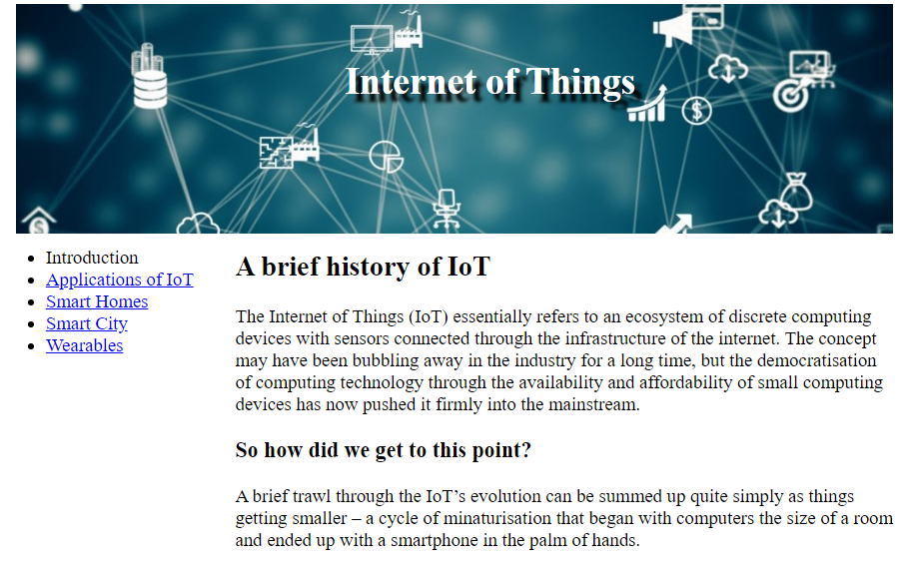

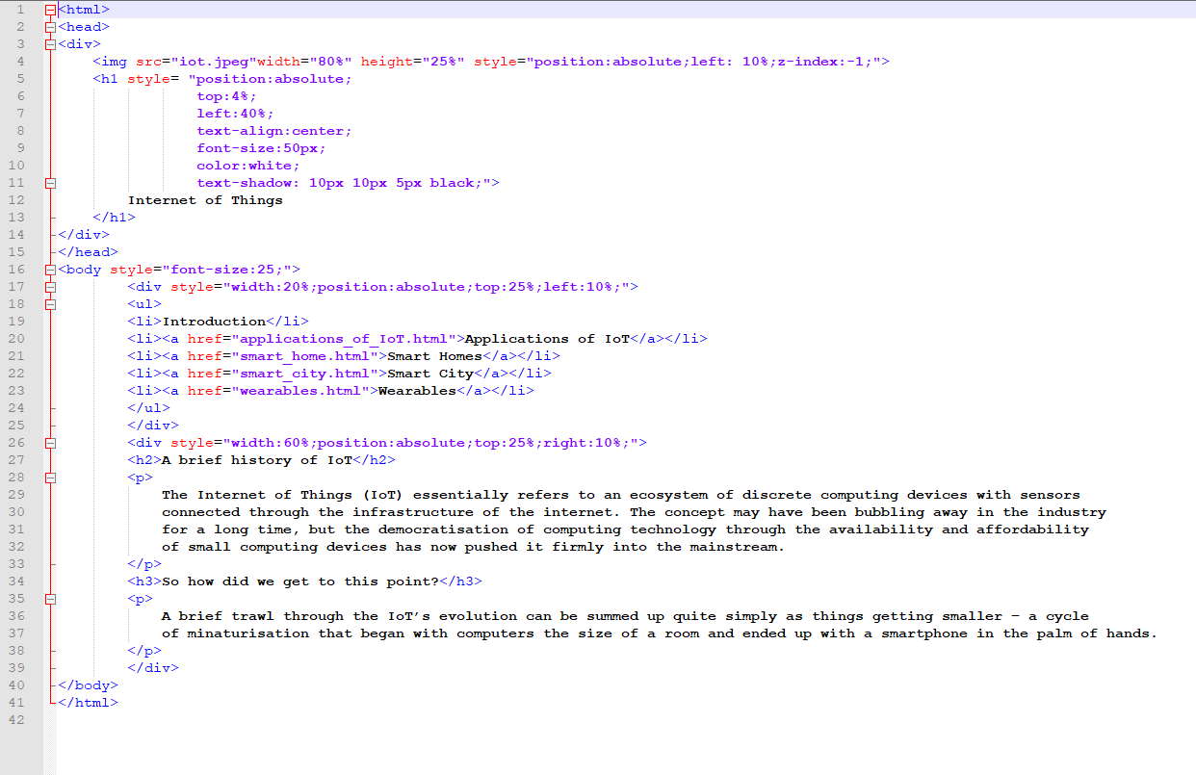

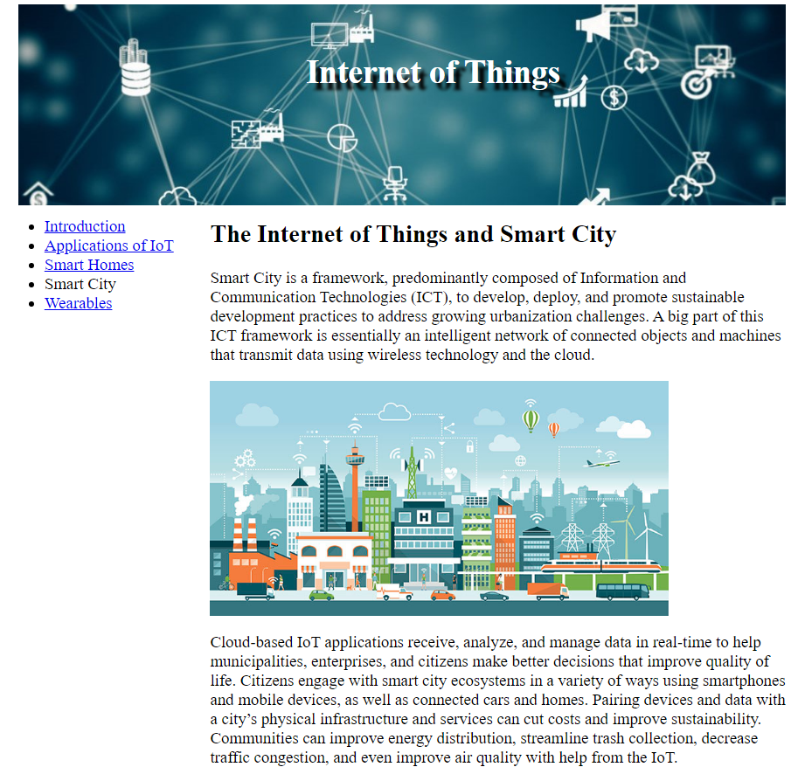

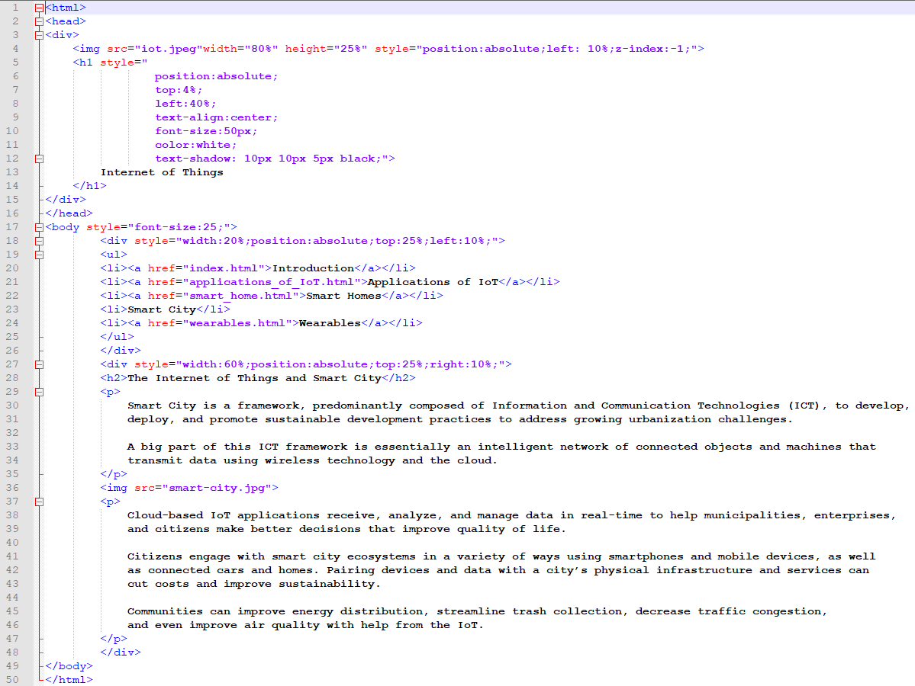

# Conclusions

In conclusion the Variety and spread of IOT applications is a fact it is almost every where you just have to know what you are looking for.